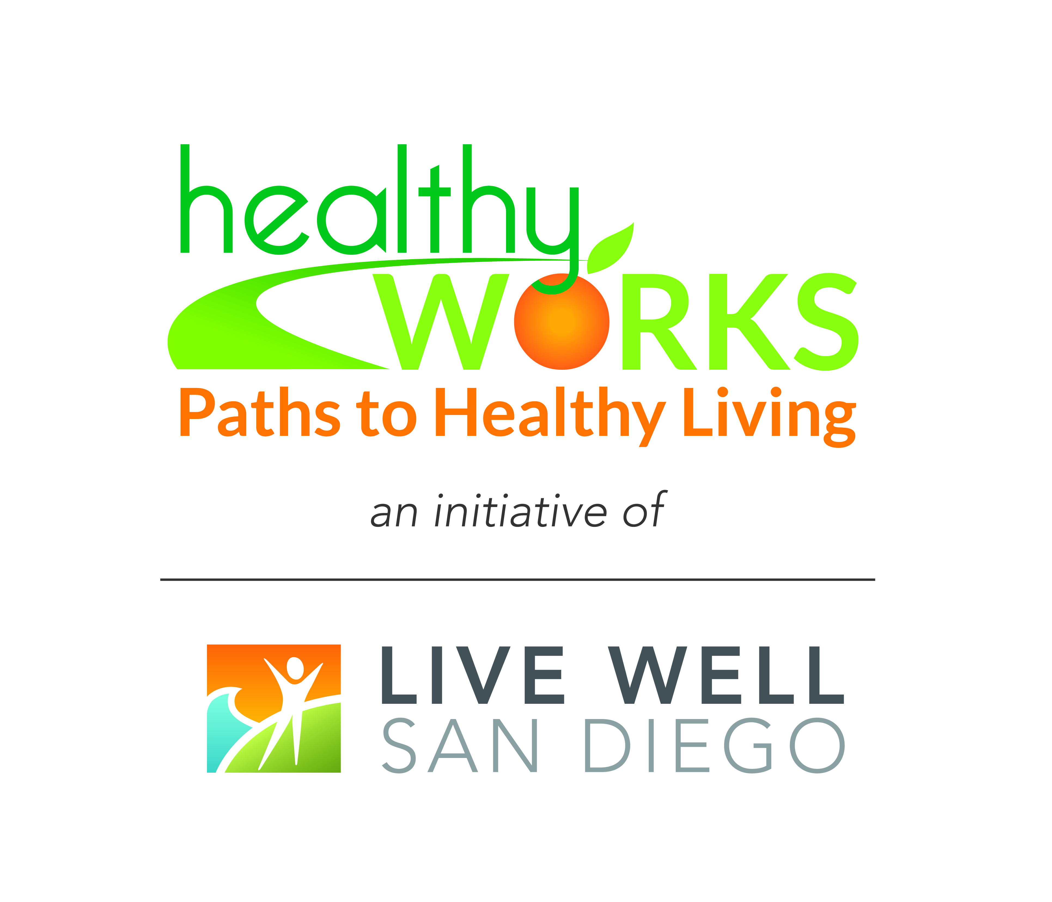
Drop-In Newsletter Communications

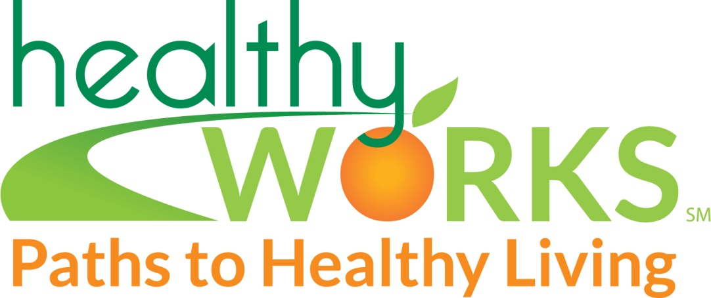

#2 - Program Launch Announcement

New Lactation Health Benefit Services Announced

[Name of Company] announces the launch of a lactation support program for women who wish to continue breastfeeding providing their infants after they return to work from maternity leave.

The lactation support program is part of the company’s health benefit services, and was developed following careful planning and review of suggestions from employees. The program includes:

- A designated safe, private area for expressing milk during work hours. The room is located [give location]
- Access to an electric breast pump for quick and efficient milk removal [describe the type of pump and milk collection kit available]
- Educational materials and classes [indicate date, time, and location]
- Monthly support group meeting [indicate date, time and location]
- Access to a lactation consultant for assistance with breastfeeding.

Research shows that supporting breastfeeding employees is a WIN-WIN for everyone. Breastfeeding is recommended by all major medical organizations as the optimal way to feed infants because of its significant health advantages. Breastfeeding is also healthier for mothers—for example, it lowers the risk of breast cancer and speeds recovery from pregnancy. This all translates into positive benefits for companies, including lower health care costs.

[Name of company] is proud to join hundreds of other businesses across America who provide lactation support for their employees. We are pleased that our breastfeeding employees can successfully merge their important priorities of family and work through onsite lactation support, and we urge supervisors and co-workers to lend their support.

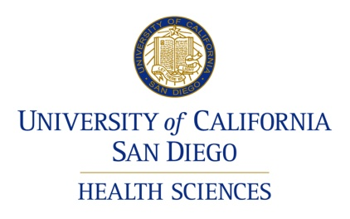


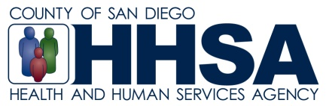

Source: Adapted from The Business Case for Breastfeeding: http://ask.hrsa.gov/detail_materials.cfm?ProdID=4135.

