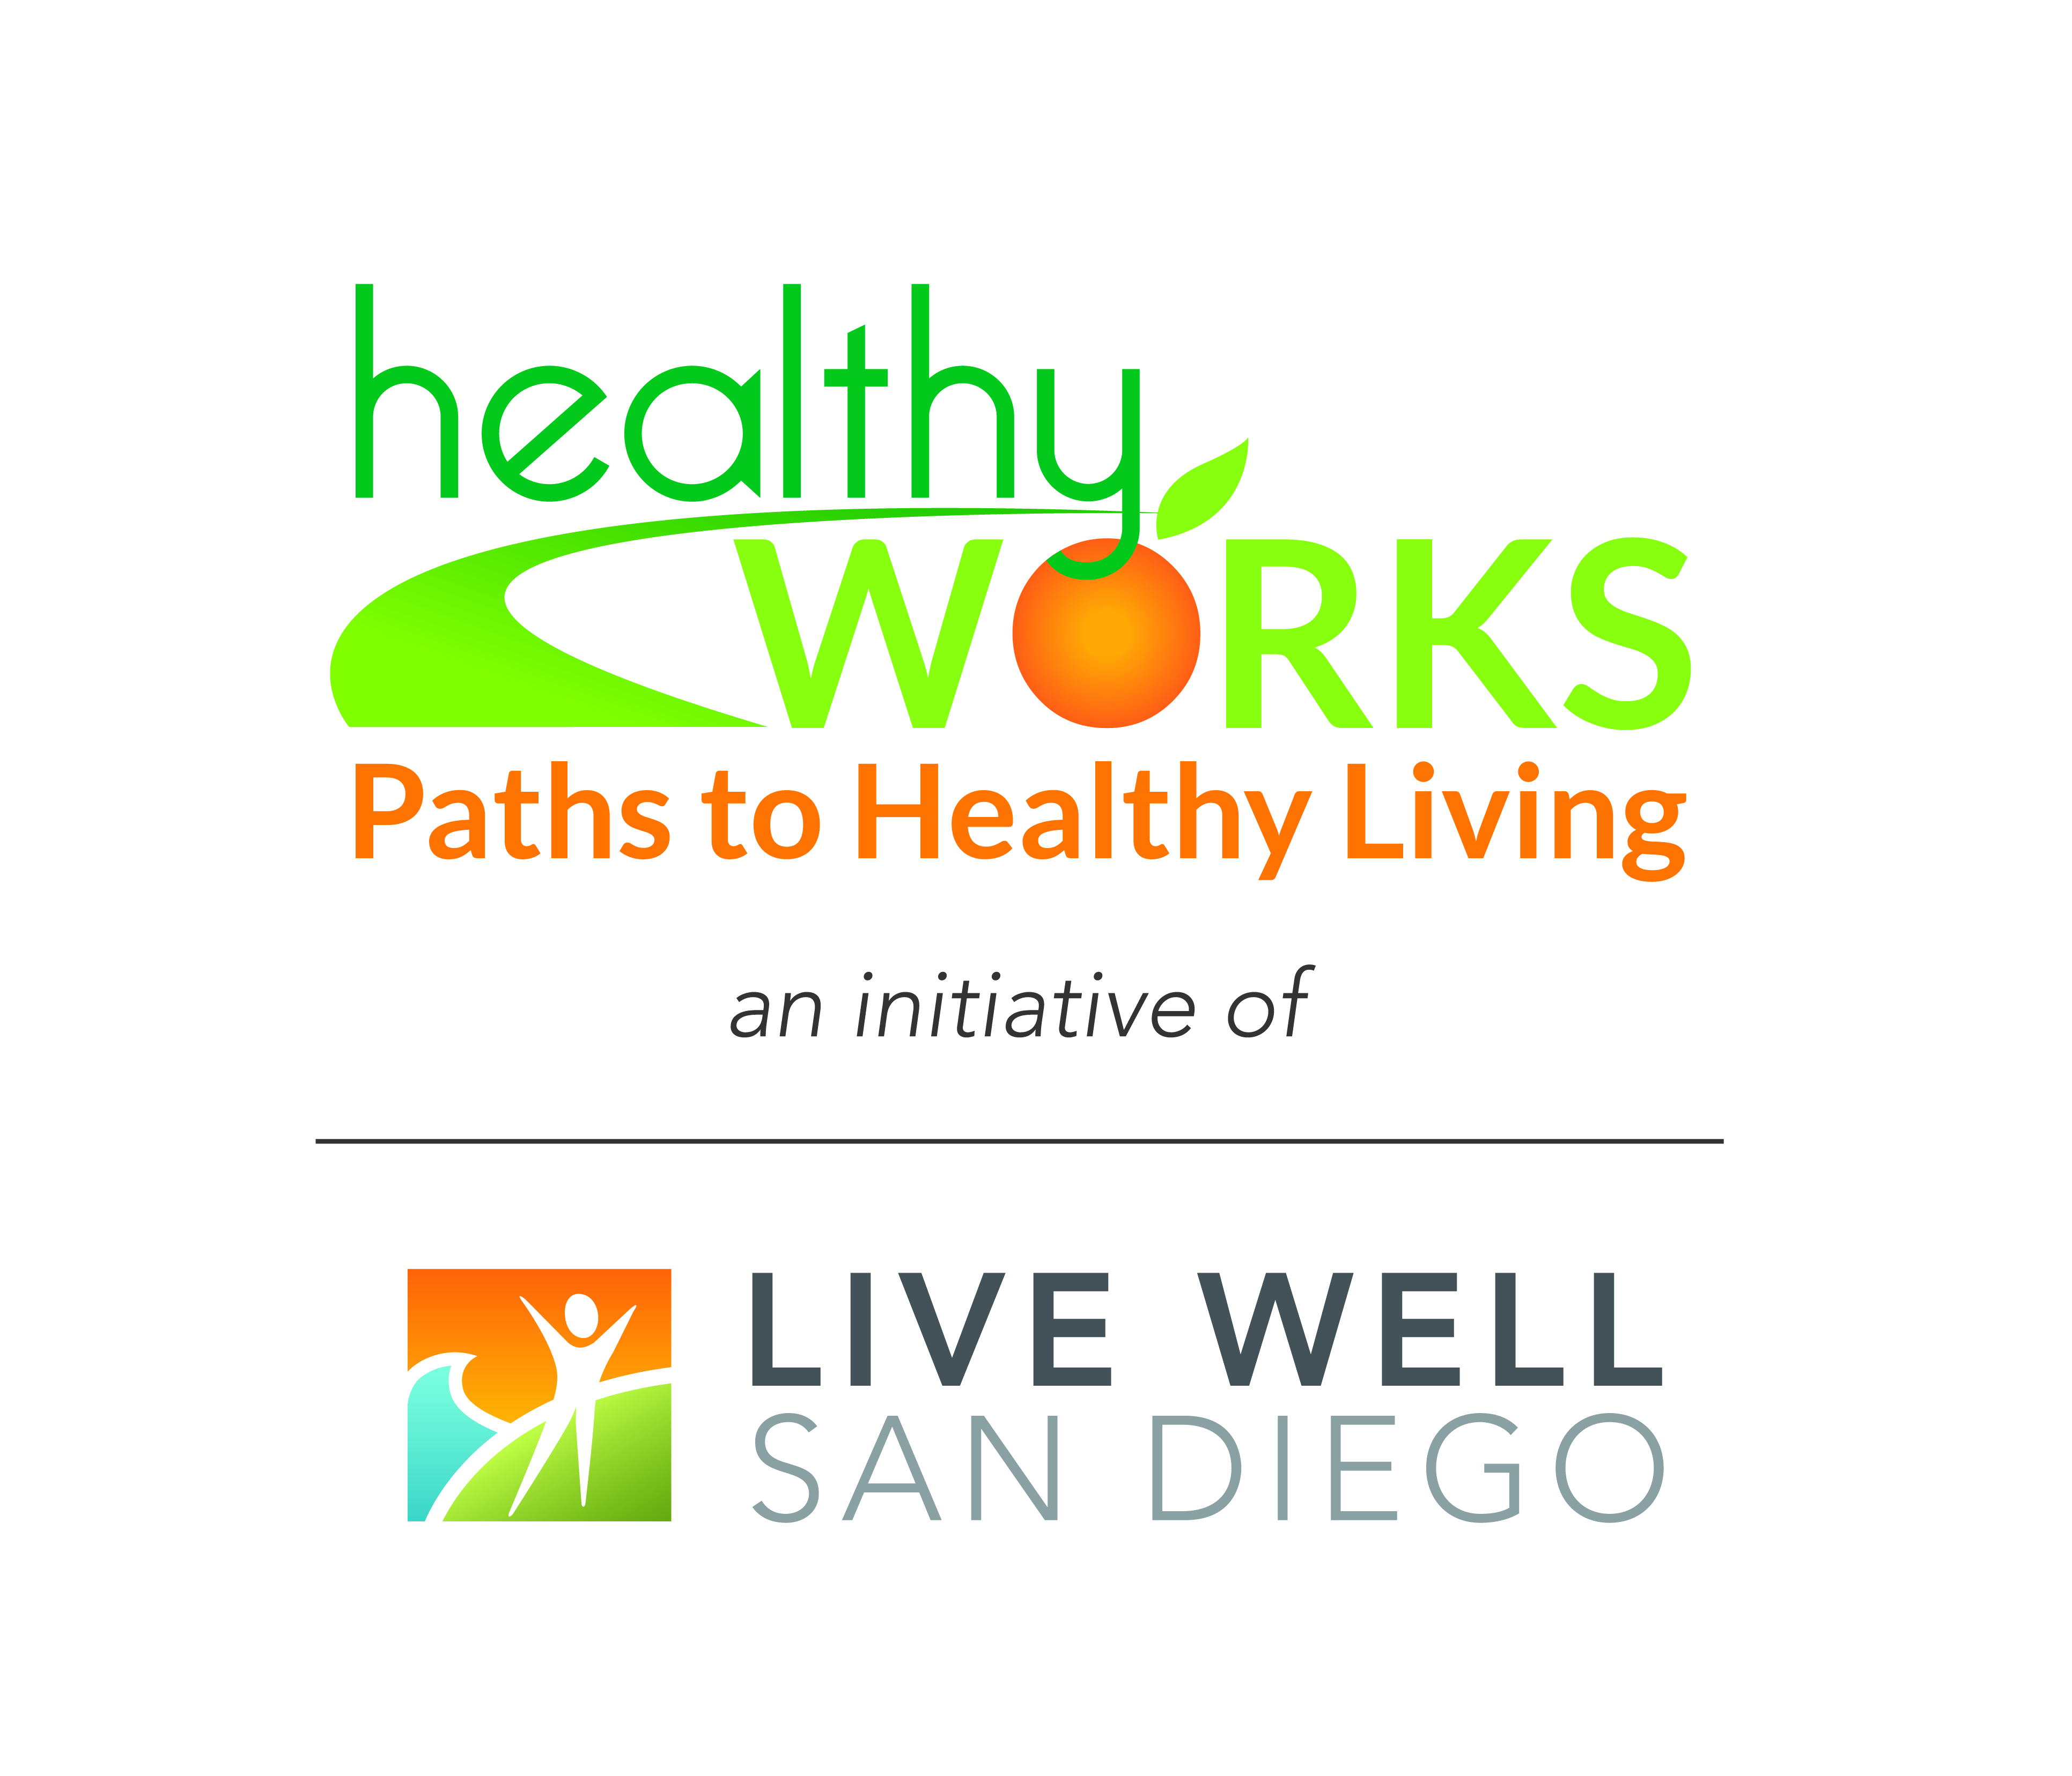
Drop-In Newsletter Communications

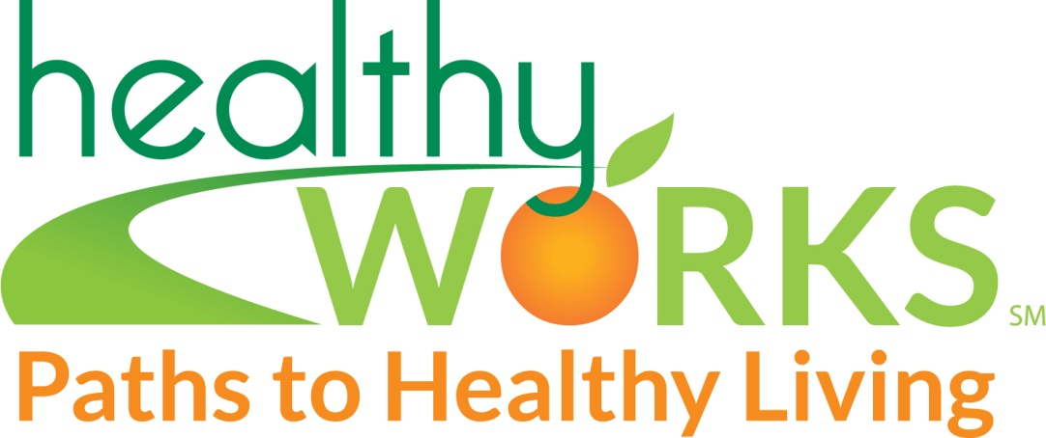

#1 - Initial Program Announcement

Merging Motherhood and Work: New Lactation Program Announced

[Name of Company] announces plans to establish a lactation support services program for employees and partners of employees who choose to breastfeed their new babies. The program will be established as part of the company’s health benefit program.

Lactation support programs are a growing trend in businesses today as a means of improving family services to employees. More than 70% of new mothers now breastfeed their infants because of the proven health benefits to both infants and mothers. Research shows that breastfed infants are significantly less likely to suffer from illnesses, infections and obesity. Mothers who breastfeed also enjoy significant health benefits, including faster recovery from pregnancy and reduced risk of breast cancer and osteoporosis. The American Academy of Pediatrics recommends that infants receive nothing but breast milk for the first 6 months of life, and continued breast milk for at least the first year or more.

Corporate lactation programs have been proven to help mothers continue to provide breast milk for their infants. These programs often include designated lactation rooms for milk expression during work hours, access to efficient breast pump equipment, education programs, and access to health professionals who can assist with questions and concerns.

If you are a pregnant or breastfeeding employee, we invite you to submit your ideas for services that will be most helpful. Any employee who would like to provide input into the process is invited to contact [name of department/contact person] with suggestions. A task force will be convened to identify needs, review suggestions, and discuss the best approach for our company. Contact our office if you would like to be a part of this task force.

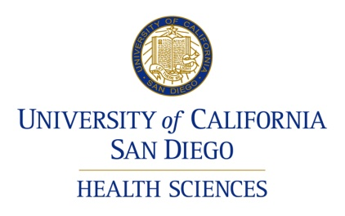

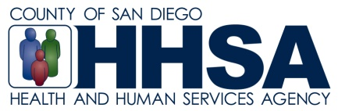

Source: Adapted from The Business Case for Breastfeeding: http://ask.hrsa.gov/detail_materials.cfm?ProdID=4135.

